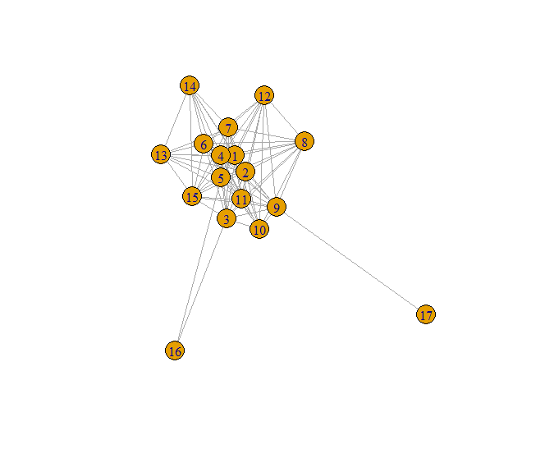

The visualization shows that certain nodes are more central and heavily connected compared to others, which might be peripheral or have fewer connections. The network also seems to have a cluster of nodes that are densely interconnected, while some nodes are more isolated.

Nodes that have many connecting edges might be key players within the network, having multiple interactions or relationships with other nodes.

Isolated nodes, or those with fewer connections, may represent peripheral entities or ones with fewer interactions.

The overall structure can suggest characteristics of the network, like whether it's centralized around a few nodes or more distributed.

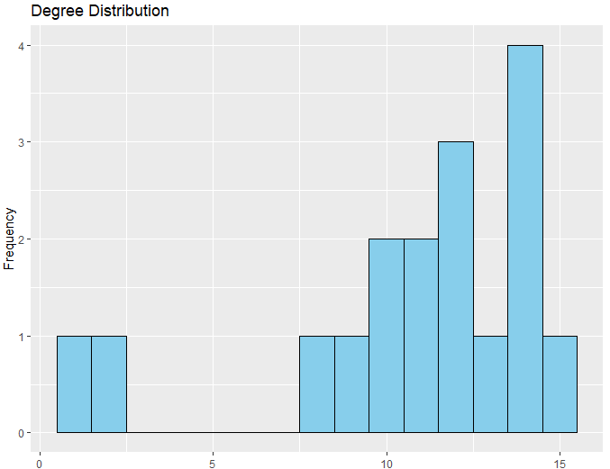

A few nodes have a low degree (near 0), which means they have very few connections within the network.

There's a range of degrees where nodes have an intermediate number of connections (around the middle of the X-axis).

There's a peak towards the right side of the histogram, suggesting there are several nodes with a high degree (around 15 connections).

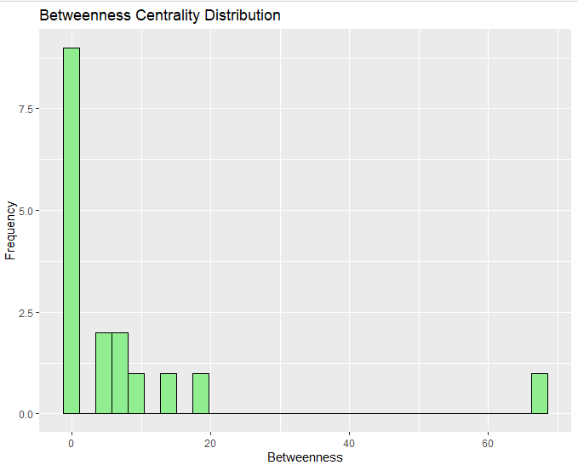

Most nodes have a low betweenness centrality score, meaning they do not often lie on the shortest paths between other nodes. This is evident from the tall bar at the beginning of the X-axis.

There are fewer nodes with a moderate betweenness centrality score.

Very few nodes have a high betweenness centrality score, as seen from the bars towards the right end of the X-axis.

**For weight:**

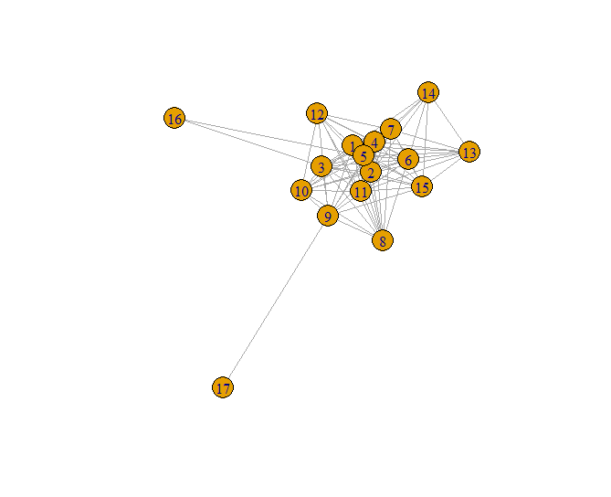

Thicker Edges: Where you see thicker lines, those edges represent stronger or more frequent interactions compared to thinner lines.

Node Connectivity: Nodes that have many edges connecting to them are likely to be more central or influential in the network.

Network Structure: The overall structure of the network can be assessed—whether it is tightly knit with many interconnections or if there are nodes that serve as hubs or bridges within the network.

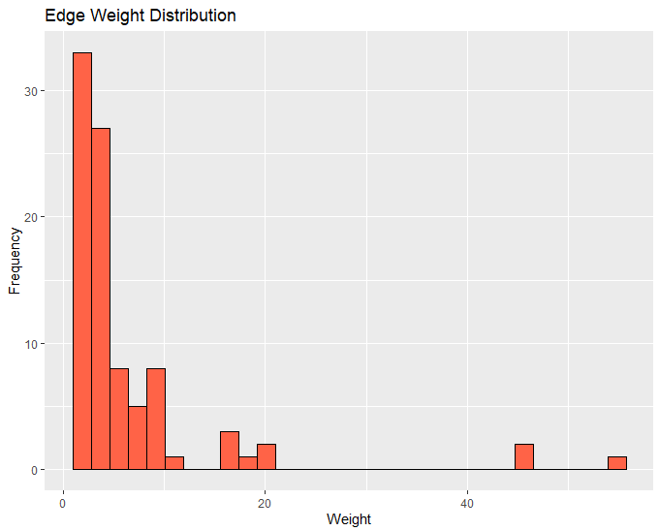

A large number of edges have a low weight (near the start of the X-axis), which suggests that most relationships in the network are of low intensity or importance.

There are fewer edges with higher weights, as indicated by the presence of bars further to the right on the X-axis but with lower heights.

There are very few edges with very high weights, as shown by the individual bars spaced out along the X-axis with even lower heights.

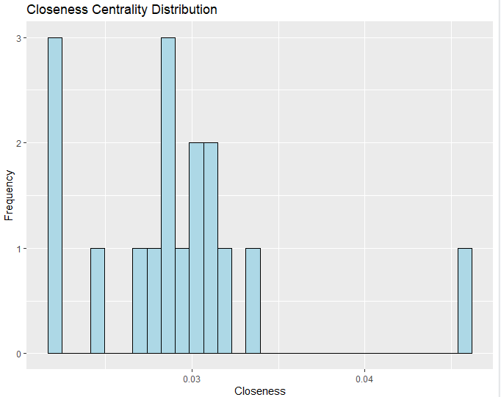

There are clusters of nodes at different levels of closeness centrality, suggesting that there are several distinct groups in terms of how centrally located the nodes are in the network.

The distribution is not uniform, indicating variability in how nodes are positioned in the network with respect to their reachability to all other nodes.

There are no nodes with very high closeness centrality scores (which would be close to 1), which suggests that no node is extremely central in terms of being close to all other nodes.